Department of Electrical and Computer Engineering
North South University



CSE445 Report

Title of your Project

Name 1 ID # xxxxxxxxxx
Name 2 ID # xxxxxxxxxx
Name 3 ID # xxxxxxxxxx

Faculty:
Riasat Khan
Assistant Professor
ECE Department

Spring, 2025

Individual Contribution Table
Section | Contributing Member Name
IEEE Word/LaTEX formatting
Grammarly check |  | Grammarly Score:
Abstract
Keywords
Introduction Motivation
Paper Review 1 |  | [3]
Paper Review 2 |  | [X]
Paper Review 3 |  | [X]
Paper Review 4 |  | [X]
Introduction Second-Last Paragraph (describe your work)
Proposed System (Dataset and Preprocessing)
Proposed System (Model description) | Decision tree
 | SVM
 | Random forest
Results and Discussion
Figure and Table Title Formatting
Conclusions
Equations formatting
References Formatting in IEEE format

Write the Title of Your CSE445 Project Report Here

Given Name Surname
Electrical and Computer Engineering
North South University
Dhaka, Bangladesh
author1@northsouth.edu
Given Name Surname
Electrical and Computer Engineering
North South University
Dhaka, Bangladesh
author4@northsouth.edu
Given Name Surname
Electrical and Computer Engineering
North South University
Dhaka, Bangladesh
author2@northsouth.edu
Given Name Surname
Electrical and Computer Engineering
North South University
Dhaka, Bangladesh
author5@northsouth.edu
Given Name Surname
Electrical and Computer Engineering
North South University
Dhaka, Bangladesh
author3@northsouth.edu
Given Name Surname
Electrical and Computer Engineering
North South University
Dhaka, Bangladesh
author6@northsouth.edu

Abstract—This electronic document is a “live” template and already defines the components of your CSE/EEE capstone project proposal report, which is due on May 01, Thursday. Explain your proposed capstone project in the abstract briefly with less than 200 words. *CRITICAL: Do Not Use Symbols, Special Characters, Footnotes, or Math in Paper Title or Abstract.
Keywords—component, formatting, style, styling, insert

Introduction
In the first paragraph, write about the problem, highlight the significance of the topic, and clearly outline the motivation behind the research. Suppose, for the Diabetes Prediction project, you should write about what diabetes is, its causes and factors, the number of diabetes-affected patients in the world and in Bangladesh, various types of diabetes, its treatment and how it is diagnosed traditionally (without ML/AI).
From the second paragraph, you will start the background or literature review. Each group member has to review at least one journal (recommended) or conference paper individually. If you have five members in your group, at least five papers have to be reviewed. You will review one paper in each paragraph individually. You can download the paper from IEEE Digital Xplore Library. Please avoid reviewing any article from a predatory journal or conference. It is strongly advised that you share this word file in GMAIL or Onedrive with all of your group members. You have to properly cite all the papers in the Reference section [1]. The authors [2] designed a website for the automatic prediction of diabetes. This work employed two open-source datasets and various popular machine learning approaches. The decision tree and random forest classifiers obtained the highest performance for this work with an accuracy of 0.968.
After writing all the literature reviews, add a new paragraph at the penultimate/second last paragraph of the Introduction section. Describe your project/work in this paragraph briefly with 5-6 sentences.
In the last paragraph, you will discuss the organization of the report. In Section II, the proposed system has been discussed with appropriate tables or figures or flowcharts. The important results for the research have been shown in Section III. Finally, Section IV concludes the paper with some directions in the future improvement of this work.

Proposed System
In this section, you will describe the theory of all the software components/algorithms as well as hardware tools which you will need for your capstone project. You can include circuit diagrams/equations or flowcharts of your capstone project.

Dataset
Write about the source with proper citation, total number of samples/instances, features of the used dataset and number of samples for each classes. You can add a table describing the dataset’s features, i.e., brief description, unit, minimum, maximum, mean, etc.
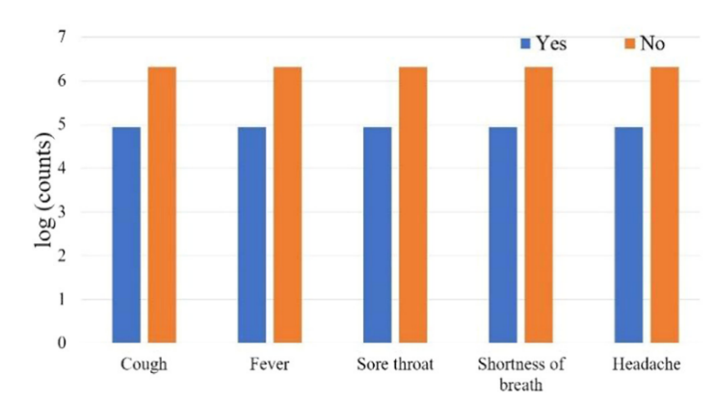
- COVID-19 test results in terms of the features in the dataset.
Fig 1 illustrates COVID-19 test results in terms of the features in the dataset. Next, you MUST add some tables and figures of EDA, e.g., histogram, scatter plot, box plot, etc.

- COVID-19 test results in terms of the features in the dataset.

Dataset Preprocessing
Write about the various dataset preprocessing techniques used in this work, i.e., missing/null and duplicate values replacement, outlier detection, feature scaling, encoding categorical data, oversampling techniques, etc. You can add some equations in this section with equation numbers. Do not forget to describe the symbols of the equations.
Add a figure of your total hardware system. Describe your figure in the text too. Number equations consecutively. Equation numbers, within parentheses, are to position flush right, as in (1), using a right tab stop. To make your equations more compact, you may use the solidus ( / ), the exp function, or appropriate exponents. Italicize Roman symbols for quantities and variables, but not Greek symbols. Use a long dash rather than a hyphen for a minus sign. Punctuate equations with commas or periods when they are part of a sentence, as in:
$y=\frac{x^{3}}{\sqrt{z}}$ 
where $x$ denotes the parameter coefficient and $z$ illustrates the slope. Note that the equation is centered using a center tab stop. Be sure that the symbols in your equation have been defined before or immediately following the equation. Use “(1)”, not “Eq. (1)” or “equation (1)”, except at the beginning of a sentence: “Equation (1) is . . .”

Machine Learning Models
Write about the used machine learning models in 3-5 sentences for each model. Do not copy from any paper or internet. You can use QuillBot for paraphrasing the sentences. You can add some equations in this section with equation numbers. Do not forget to describe the symbols of the equations.

Linear regression: Write a brief description of the ML model in 2-4 sentences.

Decision tree: Write a brief description of the ML model in 2-4 sentences.

Random forest: Write a brief description of the ML model in 2-4 sentences.
Finally, add a flowchart to describe the working sequences of this work. Do not forget to describe the flowchart. A sample flowchart of the proposed system is demonstrated in Fig. 3.
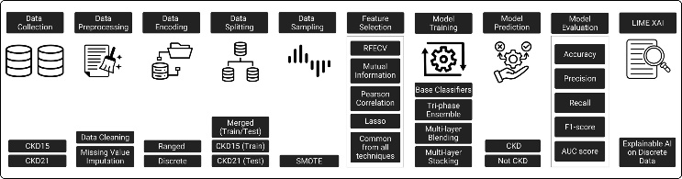
- Working sequences of the proposed diabetes prediction system.

Results and Discussion
Add circuit diagram (hardware project)/results (software project) in the “Results & Discussion” section. This is the most critical section of any research paper. You must have to discuss the results too. If you add any figure for the circuit diagram, you have to explain the key components. Please do not directly copy any figure/flowchart in this section. First, save the figure/flowchart and then use “Insert>Pictures” to add the figure/flowchart. It would be best if you use “Insert Caption” by right clicking the figure/flowchart to add the figure title.
Add a table illustrating all the features of various machine learning techniques. For hyperparameter tuning, add the values of the obtained optimized parameters too.
TABLE I. HYPERPARAMETER VALUES’ RANGES FOR VARIOUS ML MODELS
Model | Hyperparameter Value Range | Optimized value
SVM | C: [0.1, 1, 10, 100, 1000],  gamma: [1, 0.1, 0.01, 0.001, 0.0001], kernel: [linear, RBF] | C:10,  gamma:1,  Kernel: RBF
Random Forest | n_estimators: [200,500],  max_features: [auto,sqrt, log2], max_depth: [4,5,6,7,8],  criterion: [Gini, entropy] | n_estimators:450,  max_features:auto,  max_depth:8,  criterion: entropy
Logistic Regression | C: array ([1.e-03, 1.e-02, 1.e-01, 1.e+00, 1.e+01, 1.e+02, 1.e+03]), penalty: [l1, l2] | C:1.0,  Penalty:12
Decision Tree | criterion: [Gini, entropy],  max_depth: np.arange(3, 15) | criterion: entropy,  max_depth:6
KNN | n_neighbors: [1, 2, 3, 4, 5, 6, 7, 8, 9, 10, 11, 12, 13, 14, 15, 16, 17, 18, 19, 20]},  scoring=accuracy, verbose=1 | n_neighbors:11
XGBoost | max_depth: range (2, 10, 1),  n_estimators: range (60, 220, 40)  learning_rate: [0.1, 0.01, 0.05] | max_depth:2,  n_estimators:100  learning_rate:0.05
AdaBoost | base_estimator__criterion: [gini, entropy],  base_estimator__splitter: [best, random],  n_estimators: [1, 50] | n_estimators: 7

Table I illustrates the hyperparameter values’ ranges and the corresponding optimized hyperparameters for all the ML models.
TABLE II. PERFORMANCE METRICS OF VARIOUS ML MODELS WITH DEFAULT HYPERPARAMETERS
Model | Accuracy/MAE | Precision/MSE | Recall/RMSE | F1-score/R2 coefficient
SVM
Random Forest
Logistic Regression
Decision Tree

Performance metrics of various ML models with default hyperparameters have been illustrated in Table II.
TABLE III. PERFORMANCE METRICS OF VARIOUS ML MODELS WITH OPTIMIZED HYPERPARAMETERS
Model | Accuracy/MAE | Precision/MSE | Recall/RMSE | F1-score/R2 coefficient
SVM
Random Forest
Logistic Regression
Decision Tree

Performance metrics of various ML models with optimized hyperparameters have been illustrated in Table III.
TABLE IV. PERFORMANCE METRICS OF VARIOUS ML MODELS WITH OPTIMIZED HYPERPARAMETERS AND FEATURE SELECTION
Model | Accuracy/MAE | Precision/MSE | Recall/RMSE | F1-score/R2 coefficient
SVM
Random Forest
Logistic Regression
Decision Tree

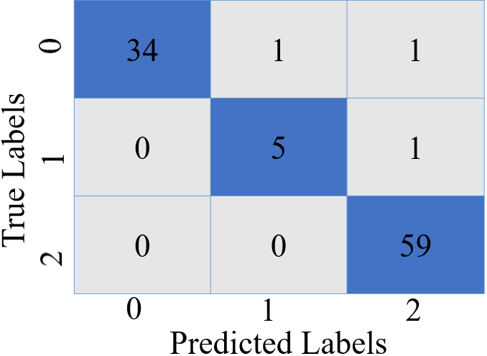
- Confusion matrix of the best performing AdaBoost model.
Fig. 4 represents the performance of the best-performing AdaBoost model, showing its classification outcomes across three classes. The model exhibits strong performance in classifying classes 0 and 2.
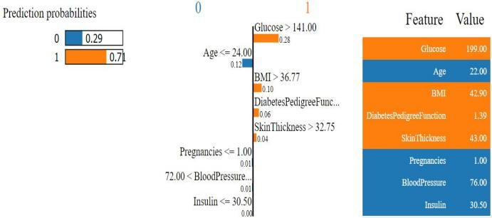
- Machine learning model prediction interpretation by LIME explainable AI library.
Fig. 5 shows the machine learning model prediction interpretation by LIME explainable AI library.
Table IV. COMPARISON OF THE PROPOSED SYSTEM WITH EXISTING WORKS
Ref. | Model | Accuracy/RMSE | Other metrics
[2]
[3]
This work

Table IV illustrates comparison of the proposed automatic diabetes prediction system with other existing works on the PIMA Indian dataset.

Conclusions
After the text edit has been completed, the paper is ready for the template. Duplicate the template file by using the Save As command, and use the naming convention prescribed by your conference for the name of your paper. In this newly created file, highlight all of the contents and import your prepared text file. You are now ready to style your paper; use the scroll down window on the left of the MS Word Formatting toolbar. Add a future work or propose how your work can be extended in the future by 1-2 sentences at the last paragraph of the Conclusions section.

References
- G. Eason, B. Noble, and I. N. Sneddon, “On certain integrals of Lipschitz-Hankel type involving products of Bessel functions,” Phil. Trans. Roy. Soc. London, vol. A247, pp. 529–551, April 1955.
- N. Ahmed et al., “Machine Learning based Diabetes Prediction and Development of Smart Web Application,” International Journal of Cognitive Computing in Engineering, vol. 2. pp. 229-241, 2021.
- I. S. Jacobs and C. P. Bean, “Fine particles, thin films and exchange anisotropy,” in Magnetism, vol. III, G. T. Rado and H. Suhl, Eds. New York: Academic, 1963, pp. 271–350.
- K. Elissa, “Title of paper if known,” unpublished.
- R. Nicole, “Title of paper with only first word capitalized,” J. Name Stand. Abbrev., in press.
- Y. Yorozu, M. Hirano, K. Oka, and Y. Tagawa, “Electron spectroscopy studies on magneto-optical media and plastic substrate interface,” IEEE Transl. J. Magn. Japan, vol. 2, pp. 740–741, August 1987 [Digests 9th Annual Conf. Magnetics Japan, p. 301, 1982].
- M. Young, The Technical Writer’s Handbook. Mill Valley, CA: University Science, 1989.
- S.L. Cloherty, N.H. Lovell, S. Dokos and B.G. Celler, “A 2D monodomain model of rabbit sinoatrial node,” Proceedings of the 23rd Annual International Conference of the IEEE Engineering in Medicine and Biology Society, vol. 1, pp. 44-47, 2001.
- M. Crawford, Catching the Sun, American Society of Mechanical Engineers, Feb. 2013. Accessed on: Nov. 12, 2019. [Online]. Available: https://www.asme.org/engineering-topics/articles/renewable-energy/catching-the-sun.
- COMSOL Conference 2006: user presentations and proceedings CD.
- DoctorKoi. Accessed on: Nov. 12, 2019. [Online]. Available: https://www.doctorkoi.com.
- Alarmy. (2017). [Online]. Available: https://alar.my.
- Edureka. Artificial Intelligence Full Course | Artificial Intelligence Tutorial for Beginners | Edureka. (June 2, 2019). Accessed: Nov. 12, 2019. [Online Video]. Available: https://www.youtube.com/watch?v=JMUxmLyrhSk.
- A. Bushra, A. Rahman, and A. Rahman, “A Multifaceted Renewable Energy Harvester for Electronic Gadgets and Mobile Phones,” B.Sc. capstone design, Dept. of Elec. and Comp. Eng., North South Univ., Dhaka, Bangladesh, 2018.

